**Mission 5:**

**Micro Musician**

**Student Workbook**



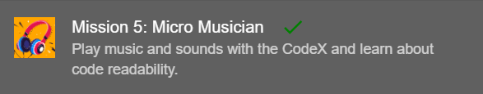

**How about some music?**

Computers and music go great together! This project brings together coding, electronics, and music. The CodeX has a built-in speaker, and there are lots of built-in tunes to play,

Go to the Mission 5 Log and fill out the Pre-Mission preparation.



**Mission 5: Micro Musician**

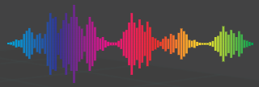

Musicians often use computers to help create music.

* Drum Machines
* Keyboard synthesizers
* Recording and Mixing with Digital Audio Workstation (DAW) Software

**Mission 5: Get started**

* Go to <https://make.firialabs.com/> and log in.



* Go to Mission 5



* Click and start Mission 5.

**Objective #1: Sound Outputs**

There are two ways to listen to sound on the CodeX.

* Built-in speaker
* Plug in headphones

The CodeX uses a **codec chip** to change digital information into audio sound waves.

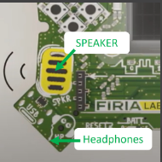

With code you can:

* Play sound files
* Beep tones
* Control volume
* And more!

**Objective #1: Sound Outputs**

**DO THIS:**

* Click on to add it to your toolbox
* Scroll down in the toolbox until you find 
* Click on it and find the table with all the   
   CodeX built-in sounds
* In your Mission Log, write down the names of sounds that you want to try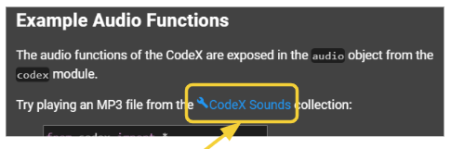

**Objective #1: Sound Outputs**

**DO THIS:**

Find the speaker and headphone jack.

**DO THIS:**

* Close the instruction panel
* Use camera controls to rotate the CodeX in the   
  scene
* Click on the speaker
* Click on the headphone jack



**Objective #2: Micro tunes**

Now it is time to write code to play some sounds.

Start by playing an mp3 file.

* An mp3 is just an audio file in the mp3 format
* The CodeX has a few sample mp3 files already loaded

Here is an example:

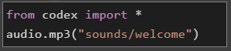



**DO THIS:**

* Create a new file called **Music1**
* Type code to play an mp3 file
* You can use the one in the example, or pick a   
  file from the sounds your are interested in trying
* Run the code



**Objective #3: Clean codes**

Good code is easy to read by people.

As your programs get longer, you can do a few things to keep them readable:

* Use blank lines to separate sections of code
  + The computer ignores blank lines
* Add comments that explain what the code does
  + The computer ignores comments



**DO THIS:**

* Add a blank line to your code
* Run the code

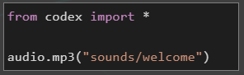

**Objective #4: Once more, with feeling**

You don’t want the screen to be blank when the sounds are playing.

* You can use **display.show()** with an image
* Use this statement BEFORE playing the mp3 file



**DO THIS:**

* Add **display.show(pics.MUSIC)**
* Change the audio file to **“sounds/africa”**
* Run your code
* Answer the question on the Mission Log

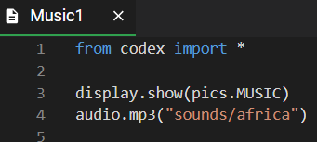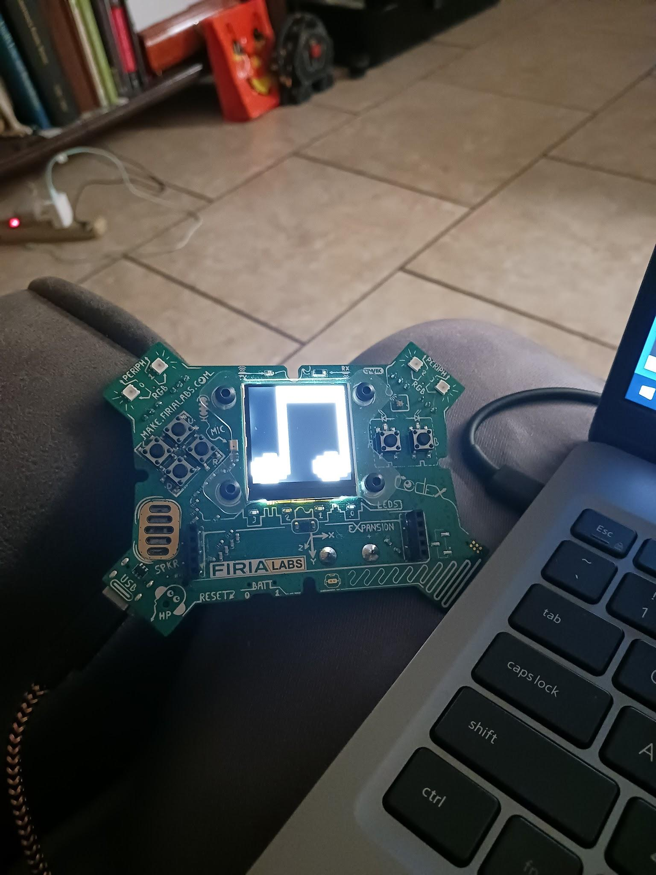

**Objective #5: Comments**

Making code readable to people was already mentioned.

You already learned about blank lines.

Now let’s find out about comments.

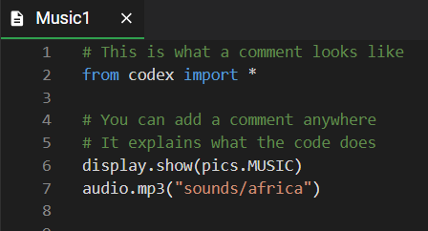

**DO THIS:**

* The instruction panel defines two words:
  + **Readability**
  + **Comments**
* Write the definitions in your Mission Log
* Click on to add it to the toolbox

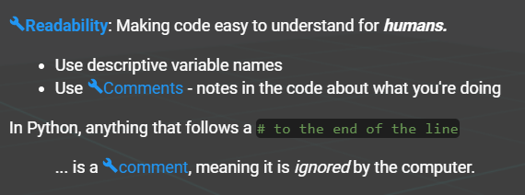

**Objective #5: Comments**

Add three comments to your code

**DO THIS:**

* Add a comment with your name at the top of   
  your code (line 1)
* Add a comment before the display.show()   
  statement (line 4)
* Add a comment before the audio.mp3()   
  statement (line 6)
* Run the code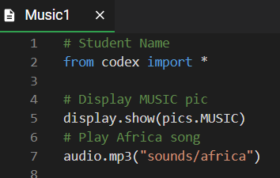



**Mission Quiz: Sounds and Readable**

Test your skills by **taking the quiz**.

**Objective #6: Portable mp3s**

After the code is running on the CodeX, you can go unplugged.

* After you run a program, it is loaded on the CodeX
* 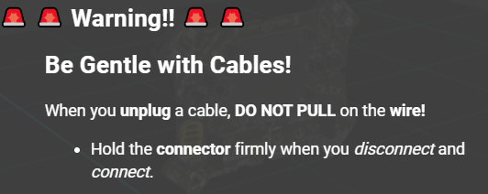You can unplug the CodeX from the computer and run on batteries

**DO THIS:**

* Close the instruction panel
* Use camera controls to rotate the CodeX   
   in the scene
* Click on the BATT switch

(OPTIONAL)

* Put batteries the CodeX
* Unplug from the computer
* 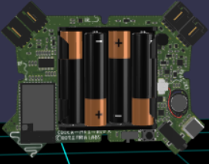Flip the BATT switch to position 1
* Enjoy your CodeX “unplugged”!

**Mission Complete**

You have completed the fifth mission. 

**Do this:**

* Read your “Completed Mission” message
* Complete your Mission 5 Log
  + Post-Mission Reflection
* Get ready for your next mission!

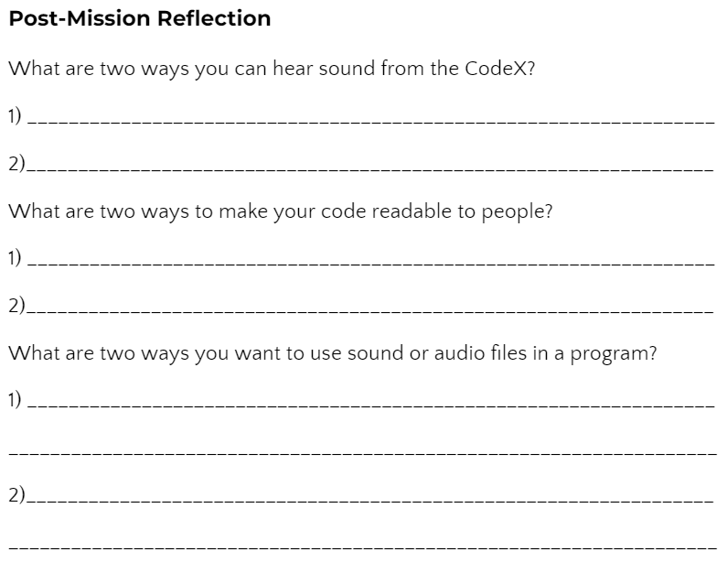

**Wait! Before you go … Clear the CodeX**

Go to FILE -- BROWSE FILES

Select the “**Clear**” file and open it

Run the program to clear the CodeX

**Okay. Now you can go.**